R Program on Confidence Interval
Q1. A sample of 400 male students is found to have a mean height 67.47 inches and standard deviation 1.30 inches. obtain 90%, 95% and 99% confidence interval for the mean height of male students.
CODE :
n=400
m=67.47
s=1.30
margin1=qnorm(1-(0.1/2))*s/sqrt(n)
margin2=qnorm(1-(0.05/2))*s/sqrt(n)
margin3=qnorm(1-(0.01/2))*s/sqrt(n)
LL1=m-margin1
UL1=m+margin1
LL2=m-margin2
UL2=m+margin2
LL3=m-margin3
UL3=m+margin3
cat("90% Confidence interval for population mean is",LL1,UL1,"\n")
cat("95% Confidence interval for population mean is",LL2,UL2,"\n")
cat("99% Confidence interval for population mean is",LL3,UL3,"\n")
OUPUT:
> n=400
> m=67.47
> s=1.30
> margin1=qnorm(1-(0.1/2))*s/sqrt(n)
> margin2=qnorm(1-(0.05/2))*s/sqrt(n)
> margin3=qnorm(1-(0.01/2))*s/sqrt(n)
> LL1=m-margin1
> UL1=m+margin1
> LL2=m-margin2
> UL2=m+margin2
> LL3=m-margin3
> UL3=m+margin3
> cat("90% Confidence interval for population mean is",LL1,UL1,"\n")
90% Confidence interval for population mean is 67.36308 67.57692
> cat("95% Confidence interval for population mean is",LL2,UL2,"\n")
95% Confidence interval for population mean is 67.3426 67.5974
> cat("99% Confidence interval for population mean is",LL3,UL3,"\n")
99% Confidence interval for population mean is 67.30257 67.63743

Q2. In a metropolitan area, the concentration of cadmium (Cd) in leaf lettuce was measured in 60 representative gardens where sewage sludge was used as fertilizer. It was found that the average content of Cd in selected samples was 18 mg/kg of dry weight with sd of 9. obtain 90%, 95%, 99% confidence interval
CODE:
n=60
m=18
s=9
margin1=qnorm(1-(0.1/2))*s/sqrt(n)
margin2=qnorm(1-(0.05/2))*s/sqrt(n)
margin3=qnorm(1-(0.01/2))*s/sqrt(n)
LL1=m-margin1
UL1=m+margin1
LL2=m-margin2
UL2=m+margin2
LL3=m-margin3
UL3=m+margin3
cat("90% Confidence interval for population mean is",LL1,UL1,"\n")
cat("95% Confidence interval for population mean is",LL2,UL2,"\n")
cat("99% Confidence interval for population mean is",LL3,UL3,"\n")

OUTPUT:
n=60
> m=18
> s=9
> margin1=qnorm(1-(0.1/2))*s/sqrt(n)
> margin2=qnorm(1-(0.05/2))*s/sqrt(n)
> margin3=qnorm(1-(0.01/2))*s/sqrt(n)
> LL1=m-margin1
> UL1=m+margin1
> LL2=m-margin2
> UL2=m+margin2
> LL3=m-margin3
> UL3=m+margin3
> cat("90% Confidence interval for population mean is",LL1,UL1,"\n")
90% Confidence interval for population mean is 16.08885 19.91115
> cat("95% Confidence interval for population mean is",LL2,UL2,"\n")
95% Confidence interval for population mean is 15.72273 20.27727
> cat("99% Confidence interval for population mean is",LL3,UL3,"\n")
99% Confidence interval for population mean is 15.00716 20.99284

Q3. A sample survey indicates that out of 3232 births, 1705 were boys and the rest were girls. Obtain 90%, 95%, 99% CI for Proportion of boys.
CODE :
n=3232
x=1705
p=x/n
q=1-p
margin1=qnorm(1-(0.1/2))*sqrt((p*q)/n)
margin2=qnorm(1-(0.05/2))* sqrt((p*q)/n)
margin3=qnorm(1-(0.01/2))* sqrt((p*q)/n)
LL1=p-margin1
UL1=p+margin1
LL2=p-margin2
UL2=p+margin2
LL3=p-margin3
UL3=p+margin3
cat("90% Confidence interval for population Proportion is",LL1,UL1)
cat("95% Confidence interval for population Proportion is",LL2,UL2)
cat("99% Confidence interval for population Proportion is",LL3,UL3)
OUTPUT:
> n=3232
> x=1705
> p=x/n
> q=1-p
> margin1=qnorm(1-(0.1/2))*sqrt((p*q)/n)
> margin2=qnorm(1-(0.05/2))* sqrt((p*q)/n)
> margin3=qnorm(1-(0.01/2))* sqrt((p*q)/n)
> LL1=p-margin1
> UL1=p+margin1
> LL2=p-margin2
> UL2=p+margin2
> LL3=p-margin3
> UL3=p+margin3
> cat("90% Confidence interval for population Proportion is",LL1,UL1)
90% Confidence interval for population Proportion is 0.5130926 0.5419816> cat("95% Confidence interval for population Proportion is",LL2,UL2)
95% Confidence interval for population Proportion is 0.5103255 0.5447488> cat("99% Confidence interval for population Proportion is",LL3,UL3)
99% Confidence interval for population Proportion is 0.5049172 0.5501571>

Q4. A random sample of 400 units using the new material was taken out of which 34 were defective units. Obtain 90%, 95%, 99% CI for Proportion of defective units.
CODE:
n=400
x=34
p=x/n
q=1-p
margin1=qnorm(1-(0.1/2))*sqrt((p*q)/n)
margin2=qnorm(1-(0.05/2))* sqrt((p*q)/n)
margin3=qnorm(1-(0.01/2))* sqrt((p*q)/n)
LL1=p-margin1
UL1=p+margin1
LL2=p-margin2
UL2=p+margin2
LL3=p-margin3
UL3=p+margin3
cat("90% Confidence interval for population Proportion is",LL1,UL1)
cat("95% Confidence interval for population Proportion is",LL2,UL2)
cat("99% Confidence interval for population Proportion is",LL3,UL3)
OUPUT:
n=400
> x=34
> p=x/n
> q=1-p
> margin1=qnorm(1-(0.1/2))*sqrt((p*q)/n)
> margin2=qnorm(1-(0.05/2))* sqrt((p*q)/n)
> margin3=qnorm(1-(0.01/2))* sqrt((p*q)/n)
> LL1=p-margin1
> UL1=p+margin1
> LL2=p-margin2
> UL2=p+margin2
> LL3=p-margin3
> UL3=p+margin3
> cat("90% Confidence interval for population Proportion is",LL1,UL1)
90% Confidence interval for population Proportion is 0.06206402 0.107936> cat("95% Confidence interval for population Proportion is",LL2,UL2)
95% Confidence interval for population Proportion is 0.0576701 0.1123299> cat("99% Confidence interval for population Proportion is",LL3,UL3)
99% Confidence interval for population Proportion is 0.04908242 0.1209176>

Q5.Following are the height of 10 children. obtain its 90%, 95% and 99% confidence interval for population mean
Height in cms: 132,125,127,131,132,141,128,122,132,140
CODE:
H=c(132,125,127,131,132,141,128,122,132,140)
m=mean(H)
s=sd(H)
n=length(H)
margin1=qt(1-(0.1/2),n-1)*s/sqrt(n)
margin2=qt(1-(0.05/2),n-1)*s/sqrt(n)
margin3=qt(1-(0.01/2),n-1)*s/sqrt(n)
LL1=m-margin1
UL1=m+margin1
LL2=m-margin2
UL2=m+margin2
LL3=m-margin3
UL3=m+margin3
cat("90% Confidence interval for population mean is",LL1,UL1,"\n")
cat("95% Confidence interval for population mean is",LL2,UL2,"\n")
cat("99% Confidence interval for population mean is",LL3,UL3,"\n")
OUTPUT:
> H=c(132,125,127,131,132,141,128,122,132,140)
> m=mean(H)
> s=sd(H)
> n=length(H)
> margin1=qt(1-(0.1/2),n-1)*s/sqrt(n)
> margin2=qt(1-(0.05/2),n-1)*s/sqrt(n)
> margin3=qt(1-(0.01/2),n-1)*s/sqrt(n)
> LL1=m-margin1
> UL1=m+margin1
> LL2=m-margin2
> UL2=m+margin2
> LL3=m-margin3
> UL3=m+margin3
> cat("90% Confidence interval for population mean is",LL1,UL1,"\n")
90% Confidence interval for population mean is 127.5112 134.4888
> cat("95% Confidence interval for population mean is",LL2,UL2,"\n")
95% Confidence interval for population mean is 126.6946 135.3054
> cat("99% Confidence interval for population mean is",LL3,UL3,"\n")
99% Confidence interval for population mean is 124.8149 137.1851
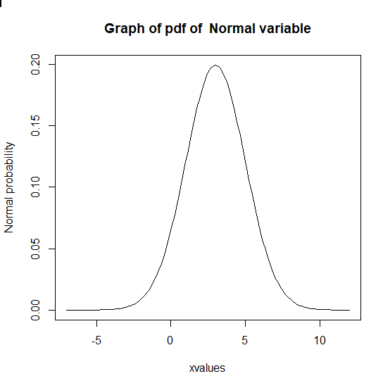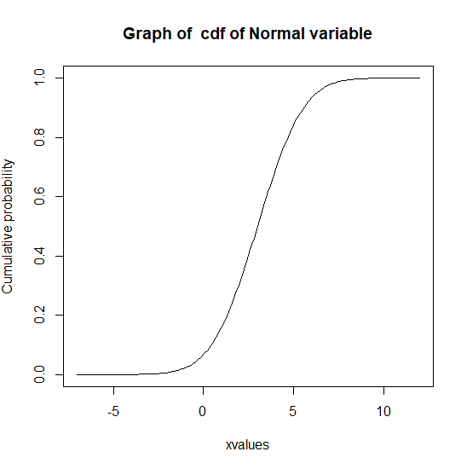
Q.6) The life tme of a battery is normally distributed with a mean life of 40 hours and a standard deviation of 1.2 hours. Find the probability that a randomly selected battery last longer than 42 hours.
CODE:
m=40
s=1.2
p1= 1- pnorm(42,m,s)
cat("p(X>42)= ",p1)

OUTPUT:
> m=40
> s=1.2
> p1= 1- pnorm(42,m,s)
> cat("p(X>42)= ",p1)
p(X>42)= 0.04779035>

Q.7) Scores on an IQ test are normally distributed. If the test has a mean of 100 and SD of 10, What is the probability that a person who takes the test will score between 90 and 110.
CODE:
m=100
s=10
p1=pnorm(110,m,s)-pnorm(90,m,s)
cat("P(90<x<110)= ",p1)

OUTPUT:
> m=100
> s=10
> p1=pnorm(110,m,s)-pnorm(90,m,s)
> cat("P(90<x<110)= ",p1)
P(90<x<110)= 0.6826895>

